LateJoiners

# 

# The Team

Luke Warren (s3409172)

Matt Grieg (s3439728)

Blair Fraser (s3641830)

Shae Tatlock (s3655740)

Tyrone Cook (s3731802)

# TipPlus Sports Tipping App

A Web application that will allow users to sign up and place their predictions of the results of a variety of sporting tournaments, and track their success against other users.

Users will be able to select from a variety of upcoming matches, with the option not just to choose the outcome, but predict scores/results as well.

The application will be available to users across a variety of devices, from desktop browsers, to tablets and mobile devices.

Table of Contents

The Team 0

Project Description 0

Core Features 2

Core Feature 1 (User accounts) 2

Core Feature 1 Validation Testing: 4

Core Feature 2 (Tournament/Match data storage) 7

Core Feature 3 (Tournament/Match display) 9

Core Feature 4 (Allow selection of picks/store picks) 5

Core Feature 4 Validation Testing: 5

Core Feature 5 (Display results/user record) 6

Core Feature 5 Validation Testing: 6

Extended Features 8

Extended Feature 1 (Source data from APIs) 8

Extended Feature 2 (Allow result crowd-sourcing) 9

Extended Feature 3 (Automated backups) 10

Project Estimation 12

Listing Technologies 13

Collaborative workspaces 13

Software 13

Tools 14

Resources 14

# Core Features

## Core Feature 1 (User Accounts)

## Login screen (desktop and mobile)

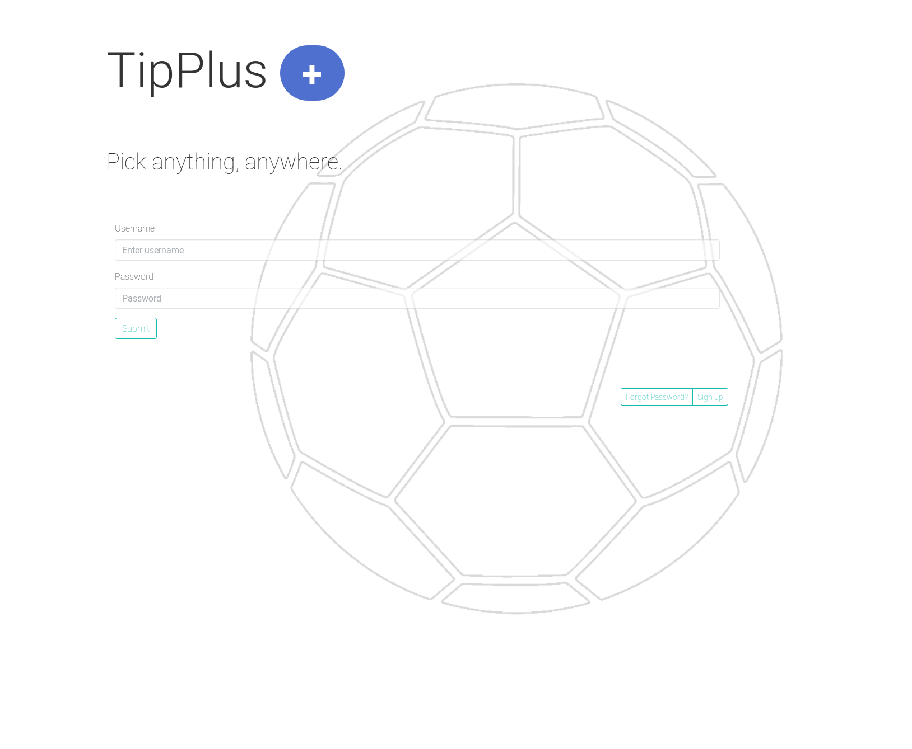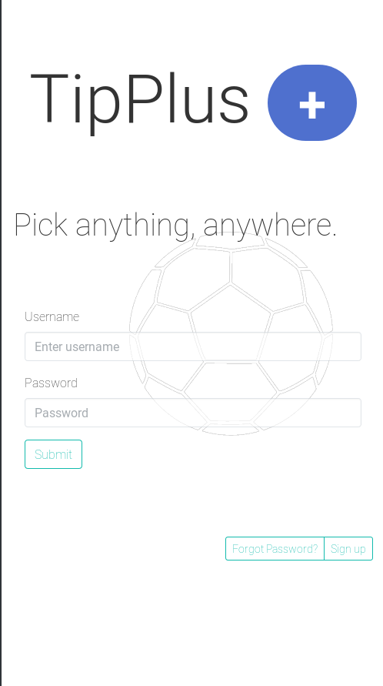

Forgot password (desktop and mobile)

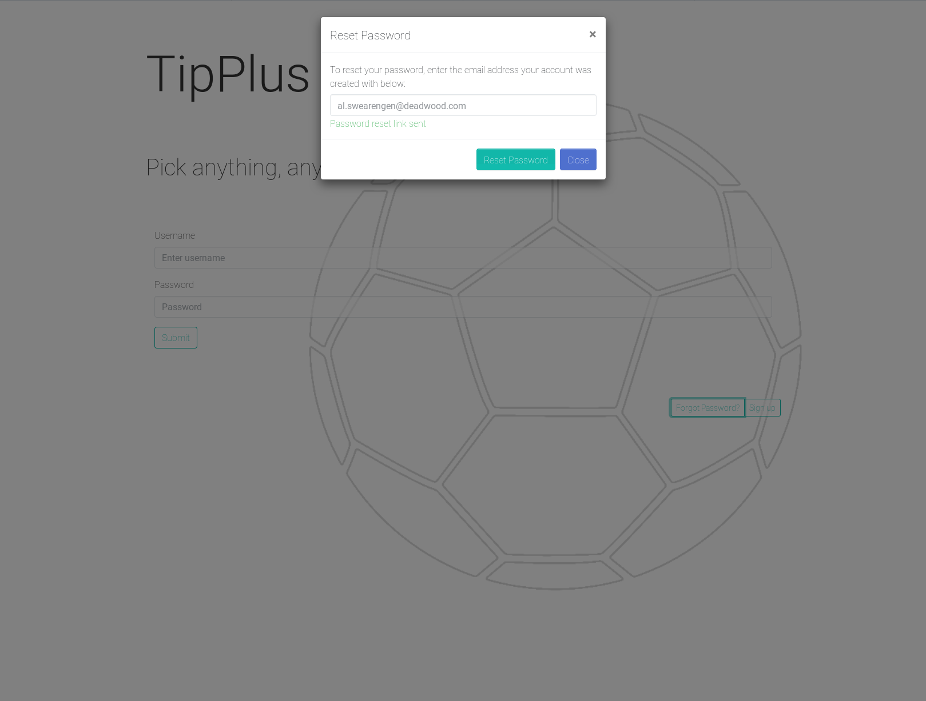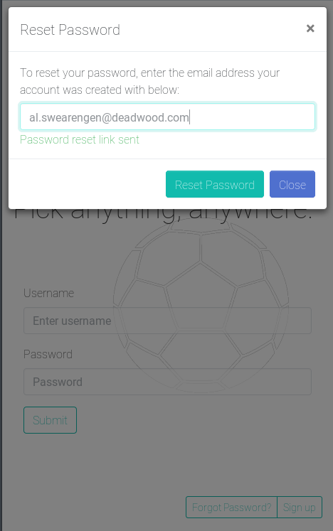

Account creation/Sign up (desktop and mobile)

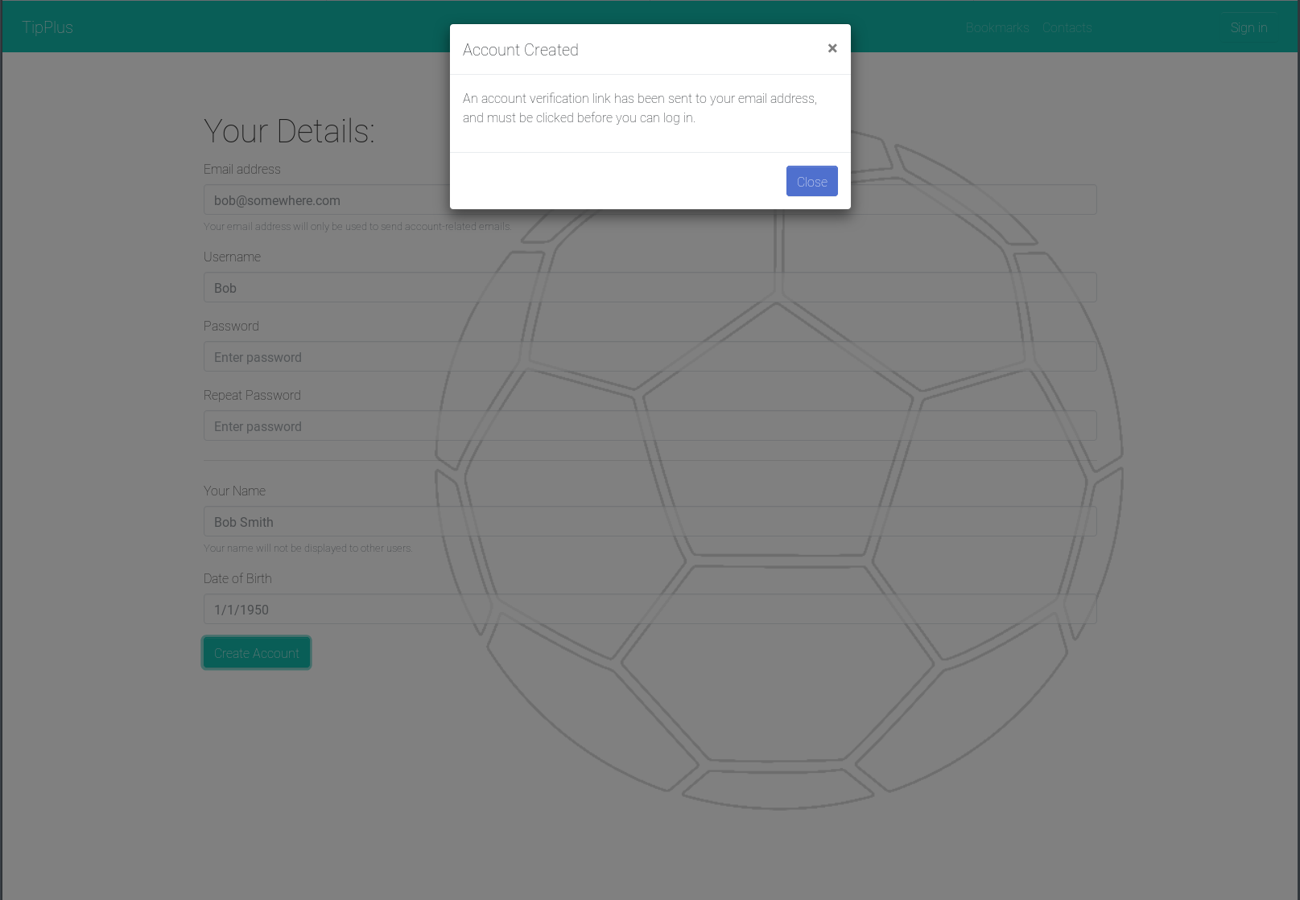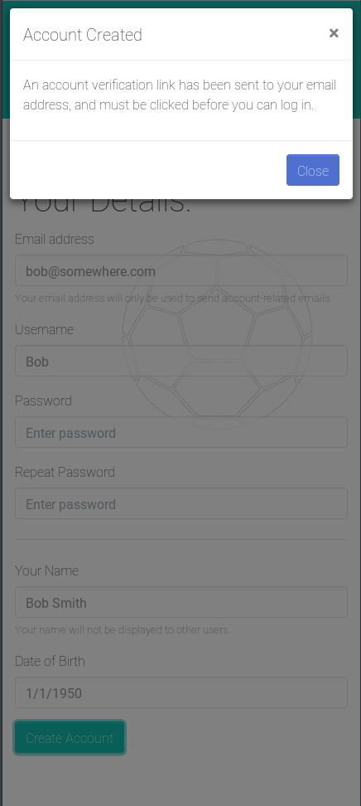

Account details screen (desktop and mobile)

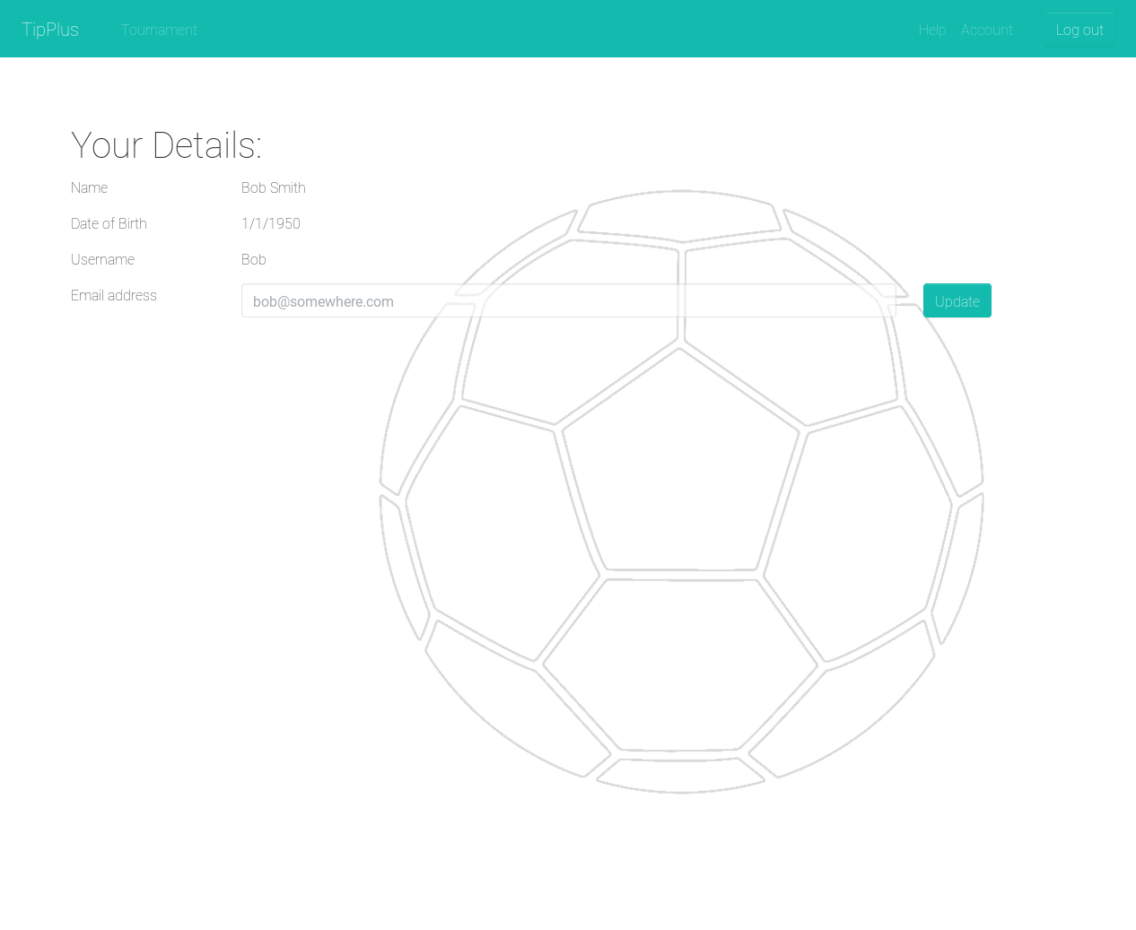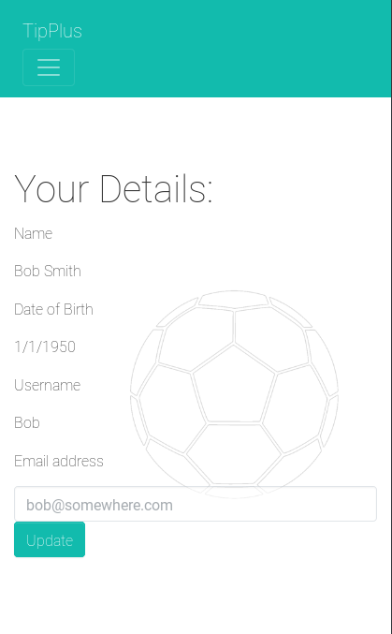

Account details screen/update email address (desktop and mobile)

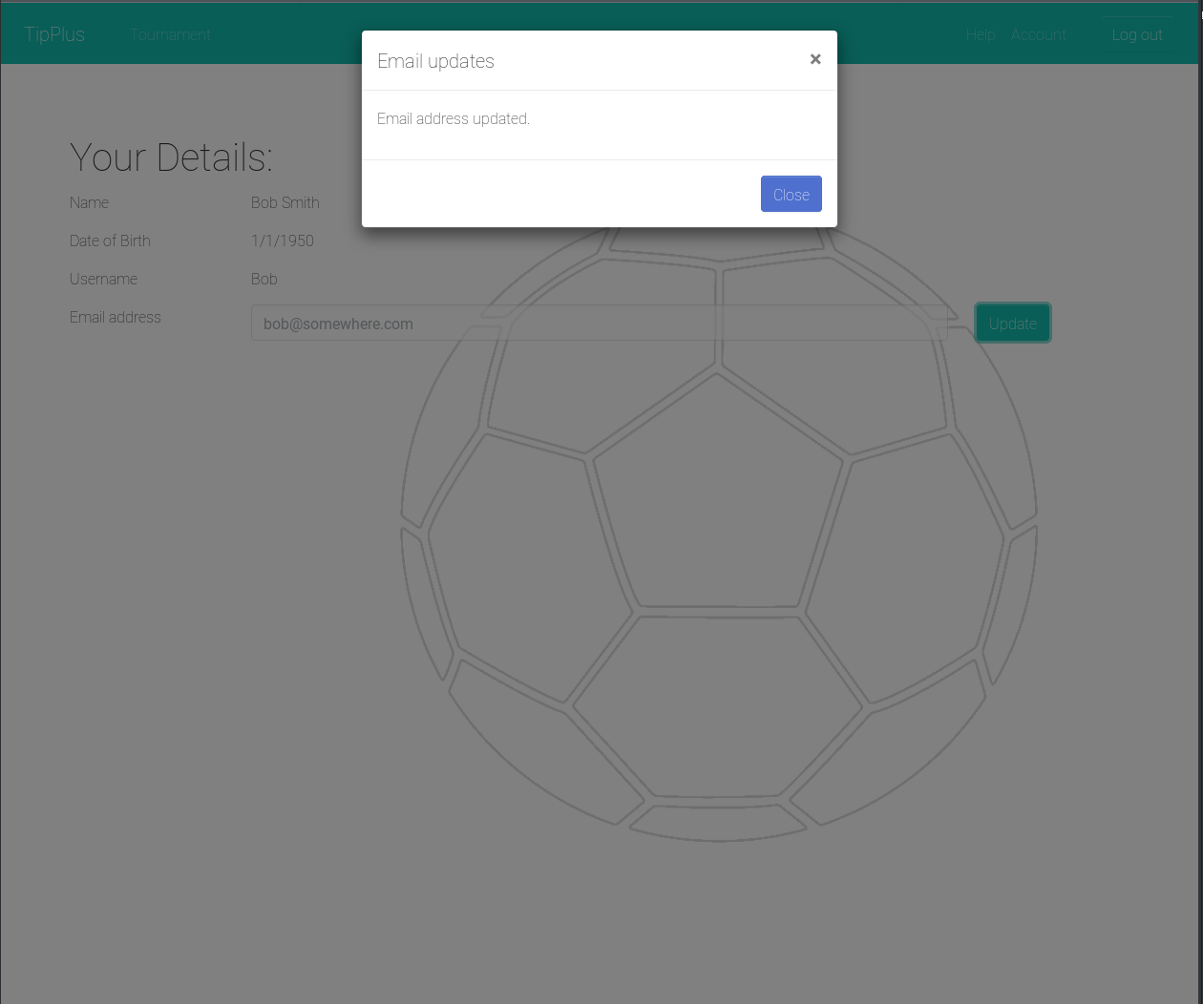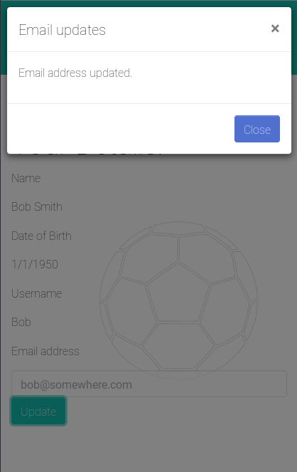

### Core Feature 1 Validation Testing:

## Login screen (desktop and mobile)

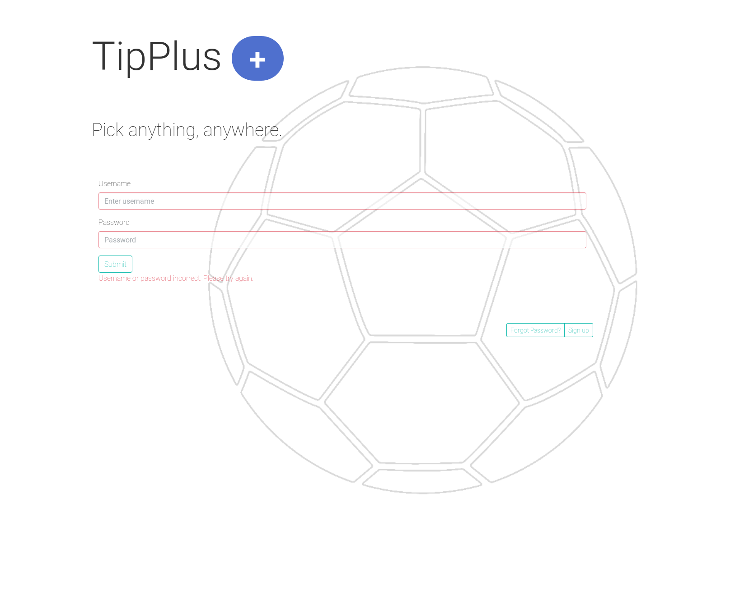

Forgot password (desktop and mobile)

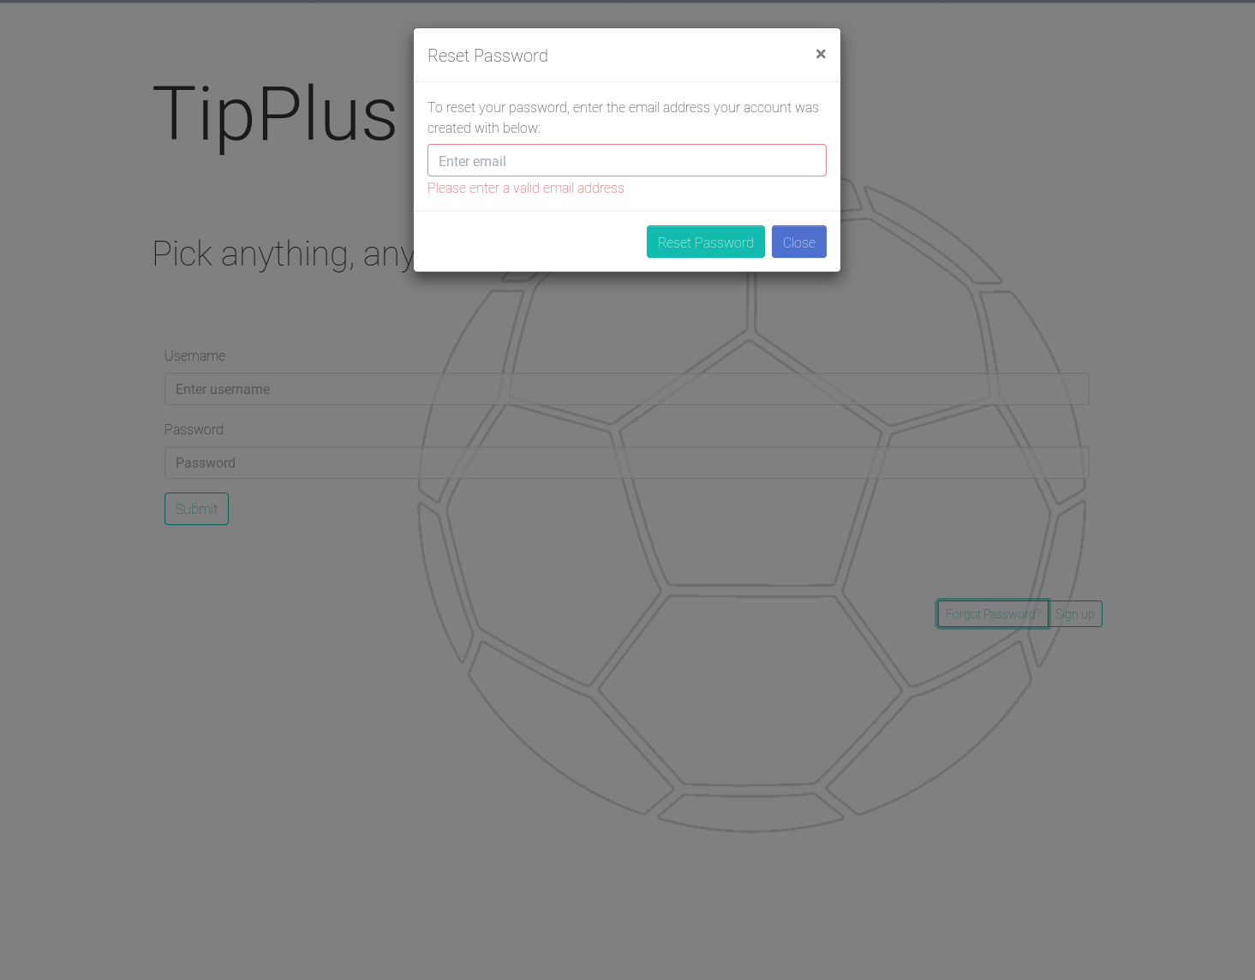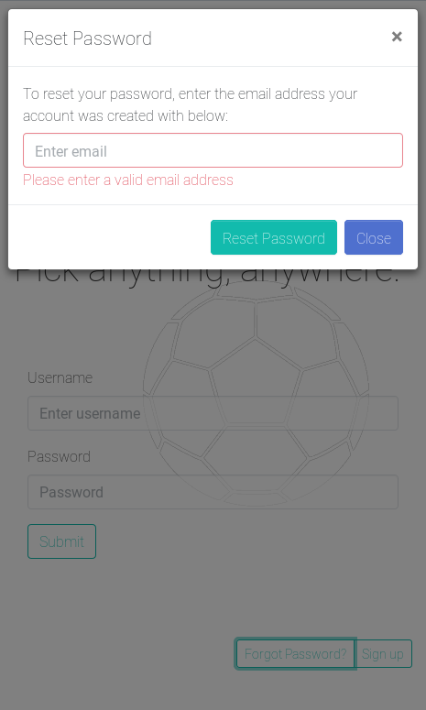

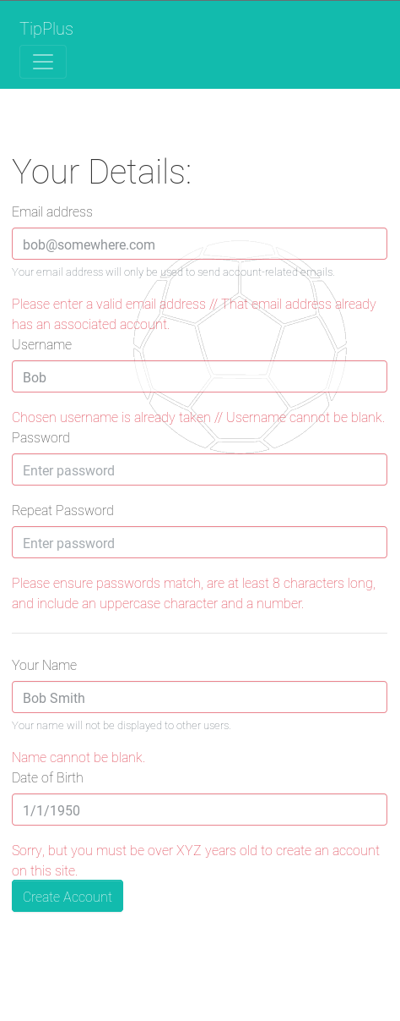

Account creation/Sign up (desktop and mobile) –

all possible error conditions shown

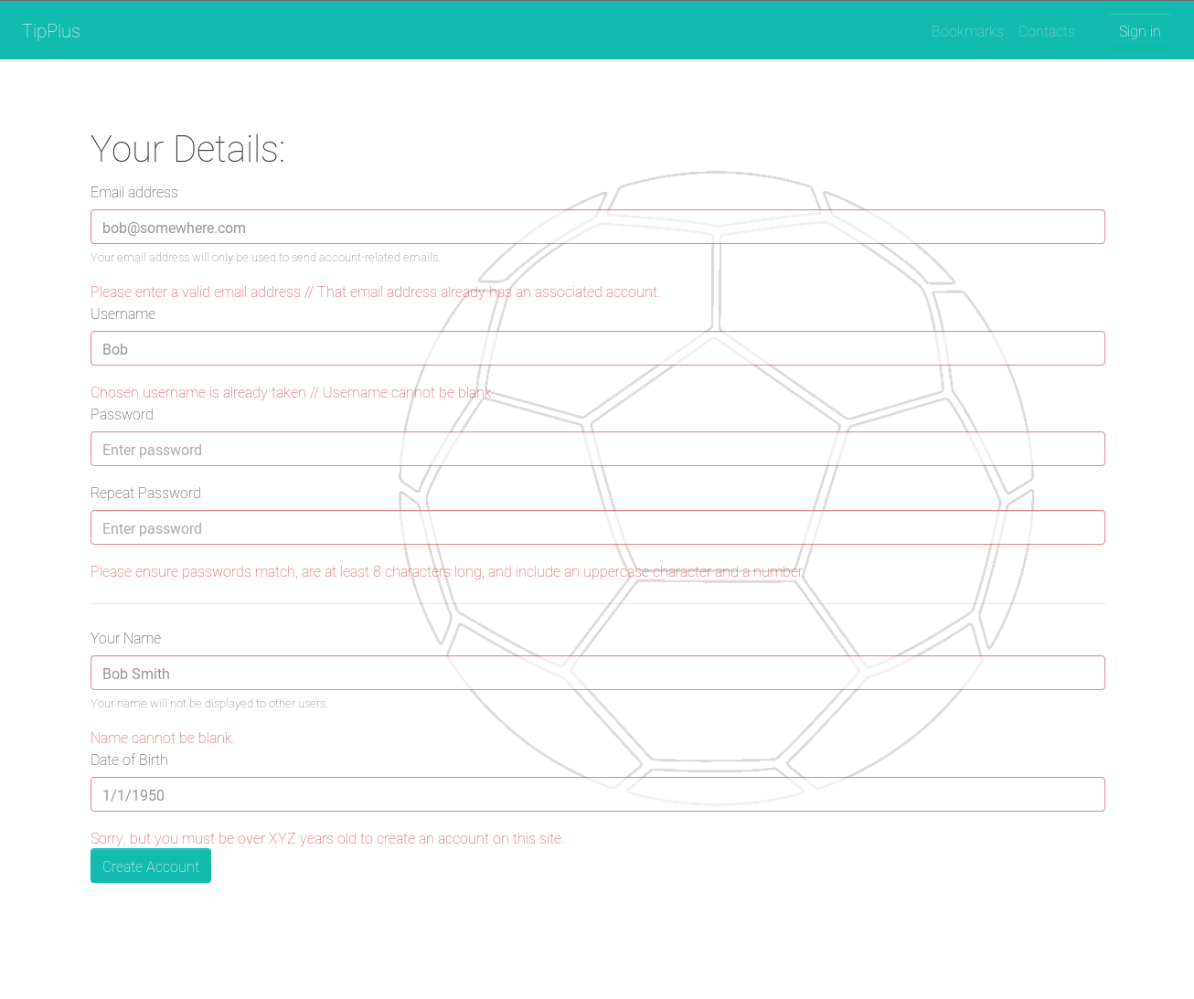

Account details screen/update email address (desktop and mobile)

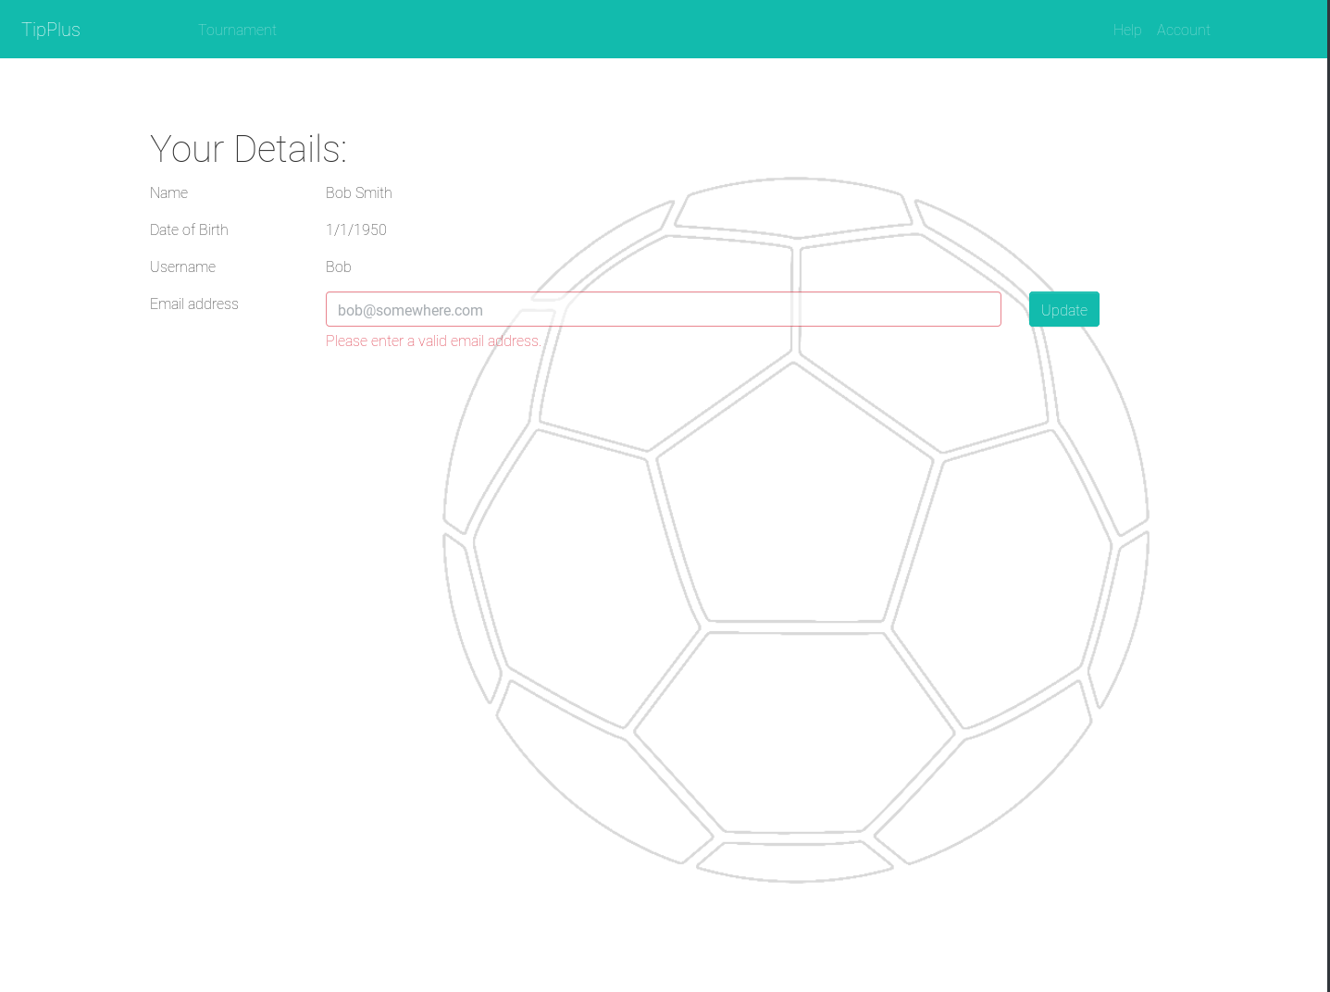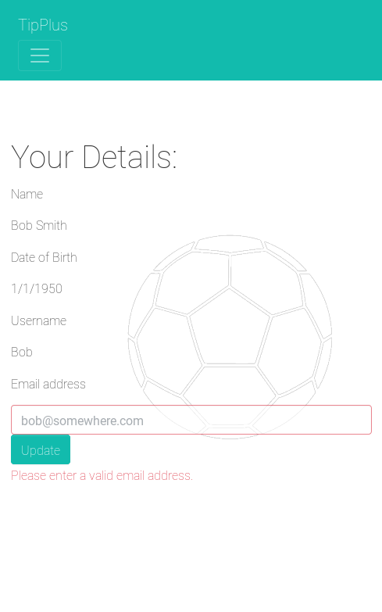

**Author:** Blair Fraser **Create Date:** 11/7/18

## Core Feature 2 (Tournament/Match data storage)

### **Database Design and Storage**

The project will be using a NoSQL databased called MongoDB. This means stepping back from normalisation in favour of fast reads and easy data manipulation.

The following is the proposed data structure for the for our MVFs:

Note - Underscores indicate a link to another piece of data in the same collection or from another collection

#### Users

* _id (GUID)
* name (string)
* password-hash (string)
* email (string)
* permissions (array of strings)
* _tournaments (array of GUIDs)
* updated by (ISO date string)
* created by (GUID)
* update on (ISO date string)
* created on (GUID)

#### Tournaments

* _id (GUID)
* name (string)
* sport (string)
* teams (array)
  + _id (GUID)
  + name (string)
  + venues (array)
    - name
    - default
* games (array)
  + _id
  + _home team (GUID)
  + _away team (GUID)
  + venue (string)
  + score
    - home team score (number)
    - away team score (number)
    - crowd provided scores (array)
      * home team score (number)
      * away team score (number)
* results (array)
  + competition leaderboard (array)
    - _team (GUID)
    - score (number)
  + picker leaderboard (array)
    - _user (GUID)
    - score (number)
* updated by (GUID)
* created by (GUID)
* update on (ISO date)
* created on (ISO date)

#### **User Picks**

* _id (GUID)
* _user (GUID)
* _tournament (GUID)
* picks (array)
  + _game (GUID)
  + home team score (number)
  + away team score (number)

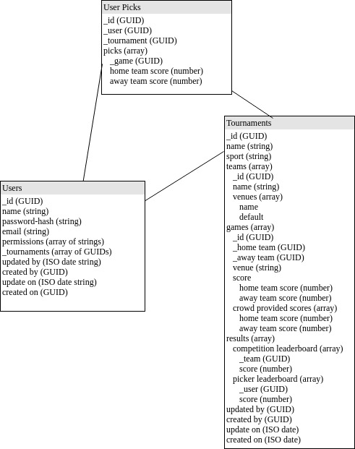

**Author:** Luke Warren

**Create Date:** 19/7/18

## Core Feature 3 (Tournament/Match display)

Desktop

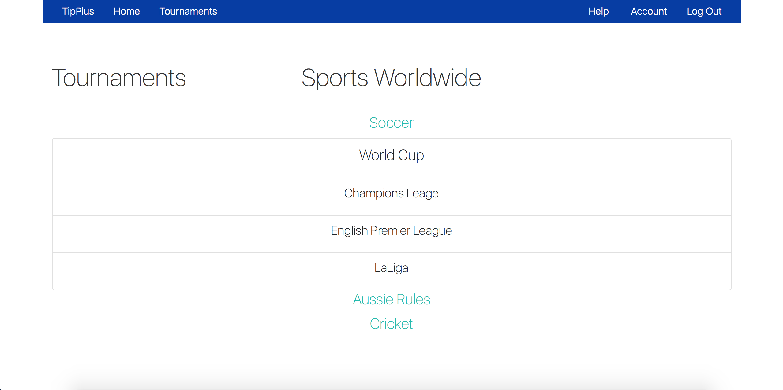

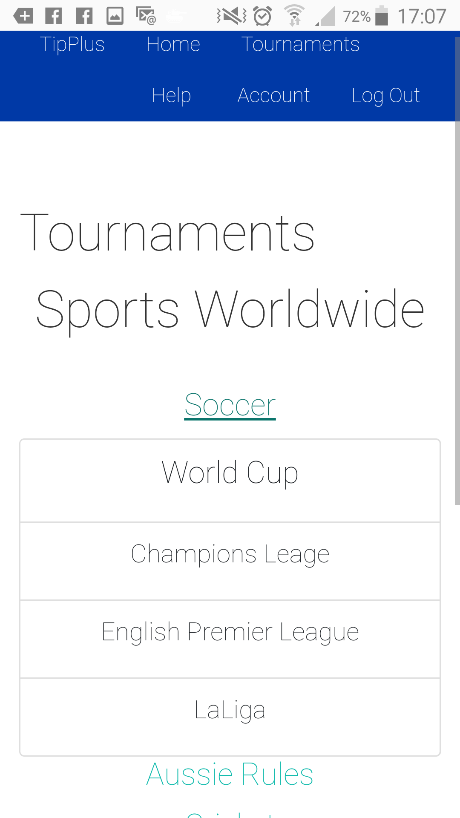

Mobile

**Author:** Shae Tatlock **Create Date:** 19/7/18

## Core Feature 4 (Allow selection of picks/store picks)

## (For storage of picks, see Core Feature 2 (Tournament/Match data storage))

Desktop

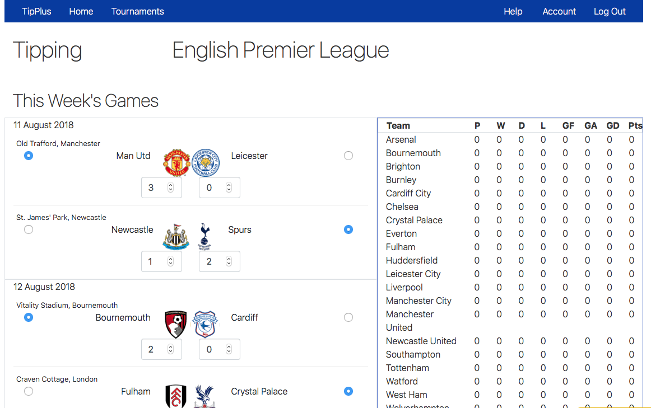

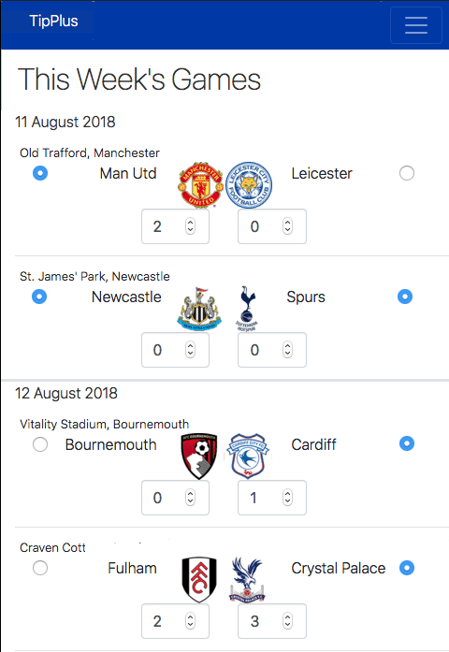

Mobile

### Core Feature 4 Validation Testing:

### Desktop

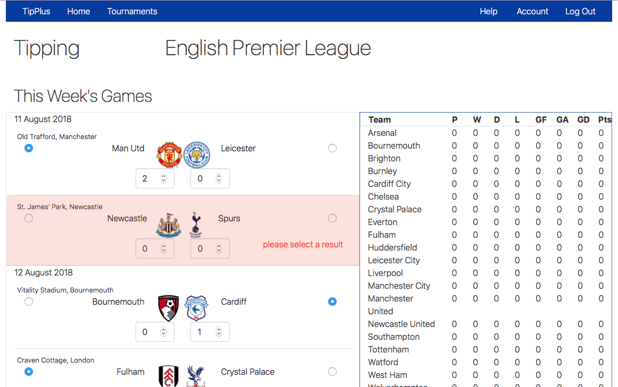

Mobile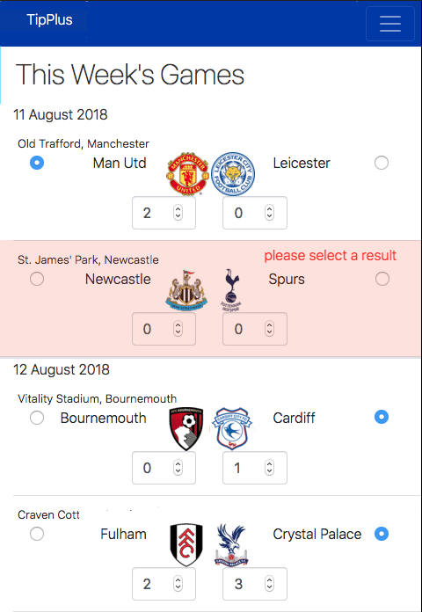

**Author:** Matt Grieg **Create Date:** 16/7/18

## Core Feature 5 (Display results/user record)

### Core Feature 5 Validation Testing:

**Author:** Tyrone Cook **Create Date:** 20/7/18

# Project Estimation

Estimations spreadsheet link:

Attached (along with this document) to the trello card at <https://trello.com/c/mpRa02Oe>

# Listing Technologies

# Collaborative workspaces

## Slack

## Chat application – group members utilize various chat channels for all official communications. All group members have slack installed on their mobile phone, and notifications enabled.

## Trello

## Team collaboration tool

## Github<https://github.com/LateJoiners>)

## Version control service

## Google Hangouts

## Used for group meetings (and mentor meetings)

## Tools/Software

## Pingendo

## Pingendo is a GUI tool that generates prototype webpages utilizing bootstrap for layout/design

## Various code editors

## Visual Studio Code, Nano and everything in between.

## Draw.IO

## A free online diagramming tool that can create UML and flow digrams, exporting to jpg, png or pdf formats.

## Frameworks

## Git

## Version control tool

## Node

## Allows use of JavaScript on the server as well as client-side. Wide array of open source packages made available by NPM (the Node Package Manager). Cross platform (team members use Windows, Linux and Mac systems).

## Angular

## Allows for rapid development of Single Page Applications. Comes with CLI tool to automate generation of boilerplate code, and can be easily hosted on the local machine, facilitating quick write/view/adjust cycles.

## MongoDB

## MongoDB is a NoSQL database which stores records (documents) as JSON objects. As such it meshes well with frameworks that are based on JavaScript.

## Express

## A REST API routing framework for Node. Express makes it easy to create backend APIs in Node.

## Bootstrap

## A front-end CSS framework for easy UI customization. Bootstrap makes it simple to generate webpages that are displayed well on both desktop and mobile devices (i.e. responsive design).

## Resources/Hosting services

## Netlify

## A hosting platform for front-end applications. Netlify provides automatic deployments.

## Heroku

## A hosting platform for backend applications. Heroku makes it easy to get up and running with node backend applications, and, like Netlify, features automatic deployments.

## Circle CI

## Online continuous integration and delivery service. Circle CI provides automatic build functionality, and automatically deploys the resulting code to heroku.

## MLab

## MLab is an online MongoDB database provider. It offers a free tier for development and QA environments, and integrated automatic backup functionality.

APPENDIX

# Extended Features

## Extended Feature 1 (Source data from APIs)

## This feature will allow the application to integrate with another tournament platform to provide scores and/or tournament information.

## 

**Author:** Luke Warren **Create Date:** 18/7/18

## Extended Feature 2 (Allow result crowd-sourcing)

**This mechanism allows our loyal user base to provide scores for games to allow quicker score turn around.**

First, we need to provide a UI mechanism for our userbase to input scores for a game. Onces a threshold of identical scores have been supplied for a game, the game result will be automatically updated.

Note - Provisions have been made for this in the database schema, see Core Feature 2, above.

**Author:** Luke Warren **Create Date:** 19/7/18

## Extended Feature 3 (Automatic Backups)

Automatic backups with will be performed on a daily basis by our database hosting provider MLab (see resources section for more info).

MLab makes it easy to automate backups of MongoDB database instances.

Backups will periodically be made and saved to an external source of our choosing.

**Author:** Luke Warren **Create Date:** 18/7/18